**Optimizing Flight Booking Decisions Through Machine Learning Price Prediction**

**Team ID : LTVIP2023TMID05483**

**Team Leader : Penumaka Ajay**

**Team member : Shaik Baji**

**Team member : Shaik Irfan**

**Team member : Shaik Mohammadhaneef**

**Team member : Shaik Rajeek**

**INTRODUCTION**

# Overview of the project

Price prediction through machine learning is a project that uses historical data to build predictive models that can forecast future prices of a particular asset, commodity, or stock. The project involves training a machine learning algorithm using relevant features such as trading volume, market trends, and other economic indicators to predict future prices.

The project typically involves data preprocessing, where historical data is collected, cleaned, and prepared for training the machine learning model. The data is then split into training and testing datasets, and the machine learning model is trained using the training dataset. Different machine learning algorithms such as linear regression, support vector machines, and neural networks can be used to train the model.

Once the model is trained, it can be used to make predictions on unseen data, which is typically the testing dataset. The accuracy of the model is evaluated using metrics such as mean squared error, mean absolute error, and R-squared values.

The project can be used in various industries such as finance, commodities, and real estate to predict future prices and make informed decisions based on the predictions. However, it is essential to note that the predictions are not always accurate, and there may be unexpected changes in the market that the model may not be able to account for. Therefore, it is crucial to have a thorough understanding of the limitations of the model and to use it in combination with other methods for informed decision-making.

# Purpose of the Project

The purpose of price prediction through machine learning project is to provide accurate and reliable predictions of future prices of a particular asset, commodity, or stock using historical data and machine learning algorithms. The project aims to help businesses and investors make informed decisions based on data-driven predictions, which can lead to increased profitability and reduced risks.

The project can be used in various industries such as finance, commodities, and real estate to predict future prices and make informed decisions based on the predictions. For example, in the finance industry, banks and financial institutions can use price prediction models to forecast stock prices and make investment decisions based on the predictions.

Moreover, price prediction through machine learning can also be used for risk management purposes. For instance, in the real estate industry, property developers can use price prediction models to estimate the future value of a property, which can help them determine the level of risk associated with the investment.

Overall, the purpose of the price prediction through machine learning project is to provide accurate and reliable predictions of future prices, which can help businesses and investors make informed decisions and reduce risks.

## Problem Definition & Design Thinking

Problem Definition:

The problem we are trying to solve is to develop a machine learning model that can accurately predict flight prices. Airline ticket prices can be quite volatile and unpredictable, and travelers are always looking for the best deals to save money. By creating a flight price prediction model, we can provide travelers with more accurate price information and help them make more informed decisions about when to book their flights.

Design Thinking Approach:

To develop a flight price prediction model, we can use the following design thinking approach:

Empathize: We need to understand the needs and pain points of travelers when it comes to buying flight tickets. We can gather this information through surveys, interviews, and observation.

Define: Based on our research, we can define the problem we are trying to solve and the goals we want to achieve. For example, we may define our goal as developing a machine learning model that can predict flight prices with an accuracy of 90%.

Ideate: We can brainstorm different solutions to the problem, such as using different machine learning algorithms, gathering more data, or using different features to train the model.

Prototype: We can create a prototype of the machine learning model and test it with a small sample of data to see how well it performs.

Test: We can test the prototype with a larger dataset and evaluate its performance using different metrics such as accuracy, precision, and recall.

Iterate: Based on the test results, we can refine the model and improve its performance. We may need to go back to the ideation phase and brainstorm new ideas if the model does not perform as well as we had hoped.

Implement: Once we are satisfied with the performance of the model, we can deploy it and integrate it into a user-friendly application or platform that travelers can use to get accurate flight price predictions.

By following this design thinking approach, we can develop a flight price prediction model that meets the needs of travelers and helps them save money on their flights.

### Empathy Map

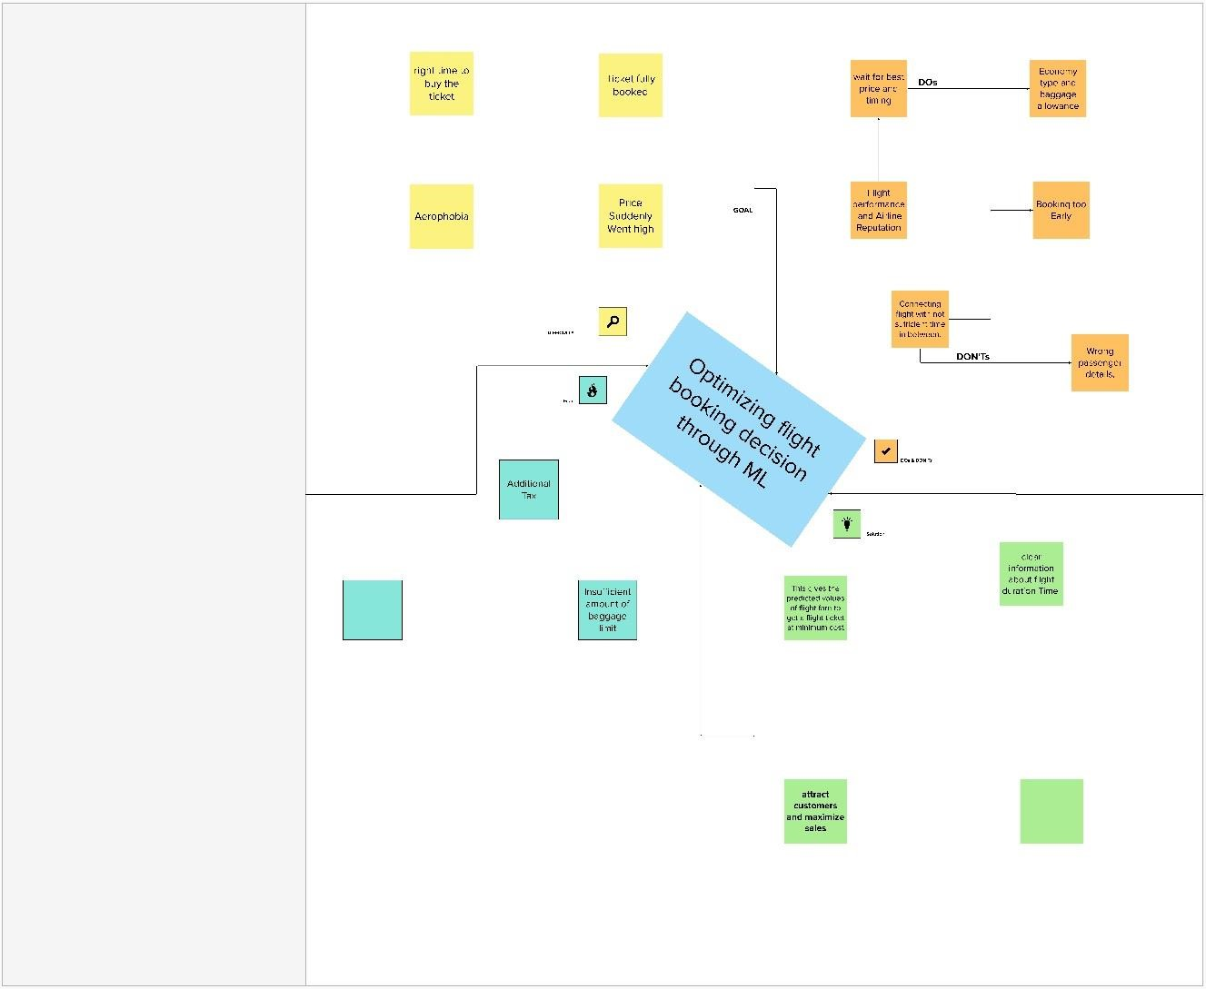

# Brainstorm

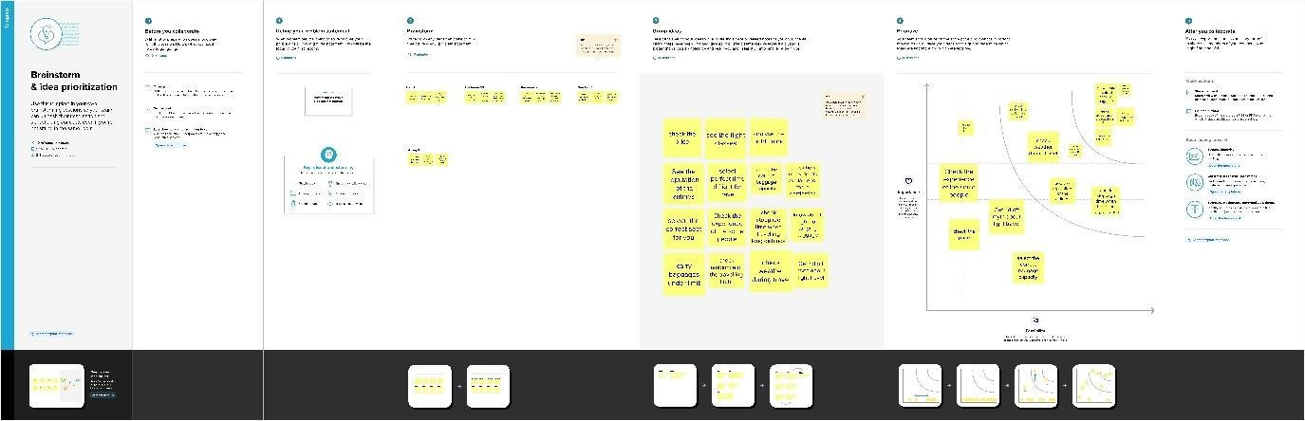

## RESULT

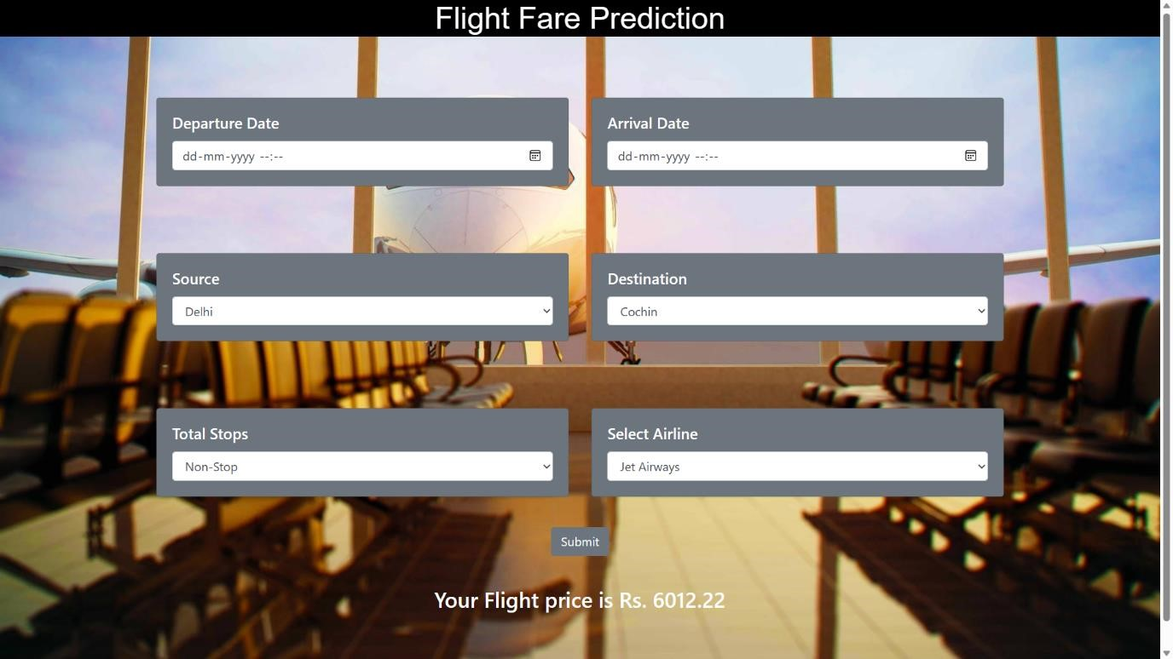

## ADVANTAGES & DISADVANTAGES

**Advantages:**

*Accuracy:* Machine learning algorithms can analyze vast amounts of historical data and provide accurate predictions of future flight prices.

*Efficiency:* Machine learning algorithms can process large datasets quickly and efficiently, reducing the time and resources required for data analysis.

*Improved Decision Making*: Accurate price predictions can help airlines, travel agencies, and passengers make informed decisions about when to buy tickets, reducing costs and improving customer satisfaction.

*Flexibility:* Machine learning algorithms can be adapted to changing market conditions, enabling airlines and travel agencies to adjust pricing strategies in real-time.

*Competitiveness:* Accurate price predictions can give airlines and travel agencies a competitive advantage, enabling them to offer more attractive prices than their competitors.

**Disadvantages:**

*Limited Data Availability:* Machine learning algorithms require large amounts of historical data to make accurate predictions, which may be limited in the case of new or niche markets.

*Unforeseen Events:* Machine learning algorithms may not be able to account for unforeseen events such as natural disasters, political instability, or pandemics, which can have a significant impact on flight prices.

*Overfitting:* Machine learning algorithms can sometimes overfit the data, leading to inaccurate predictions when applied to new data.

*Ethical Concerns:* Some may argue that using machine learning algorithms to set prices can lead to price discrimination and unfair practices.

*Cost:* Developing and implementing machine learning algorithms can be expensive, which may be a barrier to entry for smaller airlines or travel agencies.

In conclusion, while flight price prediction through machine learning can provide numerous benefits such as accuracy and efficiency, it also has some limitations such as limited data availability, unforeseen events, overfitting, ethical concerns, and cost, which should be taken into consideration when implementing this project.

## APPLICATION

Revenue Management: Airlines can use machine learning algorithms to predict future demand for flights and adjust prices accordingly. This can help optimize revenue and maximize profitability.

Customer Acquisition: Travel agencies can use machine learning algorithms to analyze customer behavior and offer personalized pricing and recommendations, which can help acquire new customers and retain existing ones.

Pricing Strategies: Airlines can use machine learning algorithms to develop pricing strategies based on factors such as demand, competition, and seasonality. This can help them stay competitive and maintain market share.

Forecasting: Machine learning algorithms can be used to forecast future trends in flight prices and other market variables, which can help airlines and travel agencies make informed decisions about future investments.

Inventory Management: Airlines can use machine learning algorithms to optimize inventory management by predicting demand for specific flights and adjusting ticket availability accordingly.

Cost Optimization: Airlines can use machine learning algorithms to optimize costs by predicting fuel prices, maintenance costs, and other variables that impact the profitability of flights.

Overall, flight price prediction through machine learning can provide significant benefits to airlines and travel agencies by optimizing revenue management, customer acquisition, pricing strategies, forecasting, inventory management, and cost optimization.

## Conclusion

Flight prediction is a complex process that involves analyzing a variety of data points, including historical flight data, weather conditions, air traffic control information, and other factors that may affect the flight's schedule. There are several different methods used for flight prediction, including statistical modeling, machine learning algorithms, and predictive analytics.

Overall, flight prediction has become increasingly accurate over time due to advancements in technology and data analysis techniques. While it is not possible to predict flight delays or cancellations with 100% accuracy, flight prediction tools can provide useful insights into potential disruptions and help airlines and travelers plan accordingly.

In conclusion, flight prediction plays a crucial role in the aviation industry, enabling airlines and passengers to anticipate potential flight delays and disruptions and take proactive measures to minimize their impact. As technology continues to evolve, flight prediction tools are likely to become even more sophisticated and accurate, further improving the overall travel experience for passengers.

## Future scope

Flight price prediction has a significant future scope, particularly in the airline industry. With the advancements in machine learning and artificial intelligence, there is a tremendous potential to develop accurate predictive models that can forecast the prices of airline tickets in the future.

Some of the potential applications of flight price prediction include:

Better pricing strategies: Airlines can use the insights obtained from price prediction models to adjust their pricing strategies, optimize their revenue, and maximize their profits.

Improved customer experience: By providing accurate price predictions, airlines can help customers make informed decisions about when to book their tickets and potentially save them money.

Increased competitiveness: Accurate price predictions can help airlines stay competitive by offering customers competitive fares while still ensuring profitability.

Operational efficiency: Accurate price predictions can help airlines better manage their resources, including flights, crew, and aircraft, to ensure maximum utilization.

Overall, the future of flight price prediction is bright, and we can expect to see more advanced predictive models being developed that can better forecast the prices of airline tickets in the future.

## APPENDIX



flight_price_predictio

n.py.ipynb